Presentation Layer

**Faculty Research**

**Database**

ISTE 330.01

Team 14

Name Email

Dominico Tran dxt4298@g.rit.edu

Ellie Parobek arp6333@g.rit.edu

Kevin Lozano kxl3544@g.rit.edu

Rachael Simmonds rms1252@g.rit.edu

Vignesh Kumar vk4534@g.rit.edu

Search Screen:

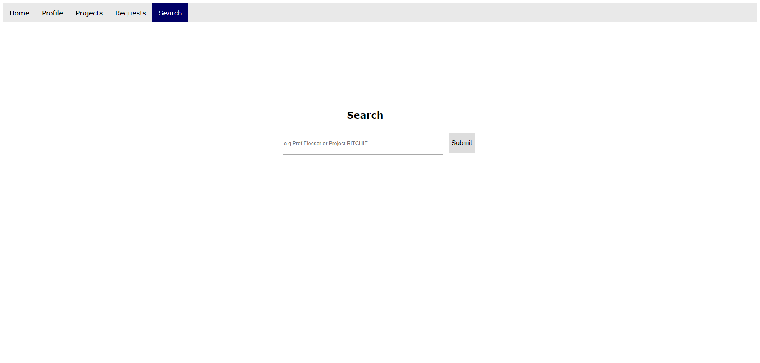

Login:

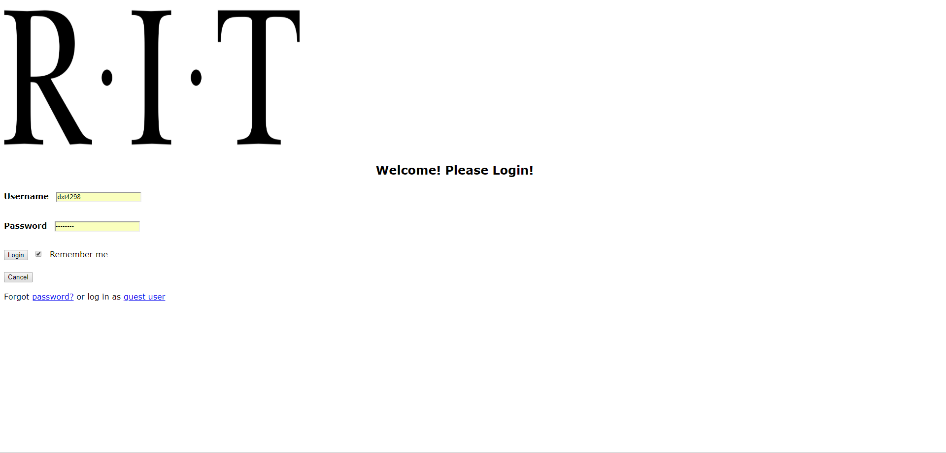

Insert:

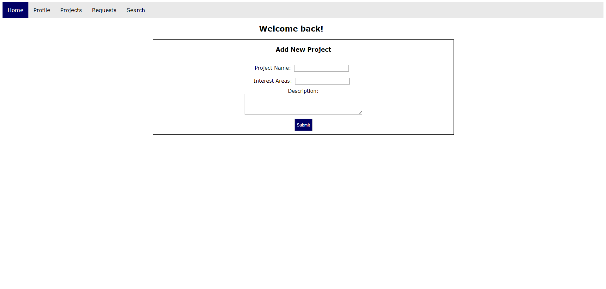

Update:

